SIMATS ENGINEERING
CSA6303- Threat Intelligence and Network Security
A1-Threat Intelligence Report
Assessment Questions
Subject | Threat Intelligence | Total Marks | 50
Questions | 5 (all compulsory) | Marks per Question | 10
Reg. No | 192365025 | Name | Kongara sai
Faculty | Dr.V.Parthipan | Slot | A
Instructions: Answer all questions. Each question carries 5 marks. Support answers with examples and diagrams where appropriate.
CO3: Perform threat analysis using intelligence models and utilize industry tools for monitoring and detection.

Code of Conduct:

I kongara sai/192365025 certify that this submission is my original work and that I have adhered to the guidelines specified for this assessment. I understand that any violation of academic integrity rules will result in disciplinary action.

Signature of Student

k.sai

Questions :
- Threat Hunting Techniques: An organization suspects that an attacker has gained unauthorized access to its internal network. The security team observes unusual login times, unexpected processes, and connections to unfamiliar external servers. Describe the proactive threat-hunting techniques you would use to investigate the activity and identify potential threats. [10]
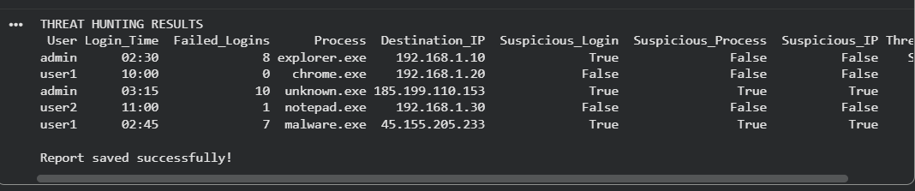
Code:
import pandas as pd
data={"User":["admin","user1","admin","user2","user1"],"Login_Time":["02:30","10:00","03:15","11:00","02:45"],"Failed_Logins":[8,0,10,1,7],"Process":["explorer.exe","chrome.exe","unknown.exe","notepad.exe","malware.exe"],"Destination_IP":["192.168.1.10","192.168.1.20","185.199.110.153","192.168.1.30","45.155.205.233"]}
df=pd.DataFrame(data)
suspicious_processes=["unknown.exe","malware.exe"]
suspicious_ips=["185.199.110.153","45.155.205.233"]
df["Suspicious_Login"]=(df["Failed_Logins"]>=5)|(df["Login_Time"]<"06:00")
df["Suspicious_Process"]=df["Process"].isin(suspicious_processes)
df["Suspicious_IP"]=df["Destination_IP"].isin(suspicious_ips)
df["Threat_Status"]=df.apply(lambda r:"HIGH RISK" if sum([r["Suspicious_Login"],r["Suspicious_Process"],r["Suspicious_IP"]])>=2 else "SUSPICIOUS" if r["Suspicious_Login"] or r["Suspicious_Process"] or r["Suspicious_IP"] else "NORMAL",axis=1)
print("THREAT HUNTING RESULTS")
print(df.to_string(index=False))
df.to_csv("threat_hunting_report.csv",index=False)
print("Report saved successfully!")

- SIEM Tools and Security Monitoring : A company implements a Security Information and Event Management (SIEM) system to monitor its network. The system generates multiple alerts about suspicious login attempts and unusual outbound connections. Explain how the SIEM system can collect and analyze security events, correlate alerts, and help security analysts prioritize potential threats. [10]
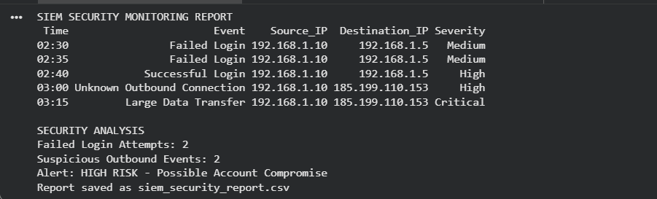
import pandas as pd
data={"Time":["02:30","02:35","02:40","03:00","03:15"],"Event":["Failed Login","Failed Login","Successful Login","Unknown Outbound Connection","Large Data Transfer"],"Source_IP":["192.168.1.10","192.168.1.10","192.168.1.10","192.168.1.10","192.168.1.10"],"Destination_IP":["192.168.1.5","192.168.1.5","192.168.1.5","185.199.110.153","185.199.110.153"],"Severity":["Medium","Medium","High","High","Critical"]}
df=pd.DataFrame(data)
print("SIEM SECURITY MONITORING REPORT")
print(df.to_string(index=False))
failed=df[df["Event"]=="Failed Login"].shape[0]
outbound=df[df["Event"].str.contains("Outbound|Data Transfer",case=False)].shape[0]
print("\nSECURITY ANALYSIS")
print("Failed Login Attempts:",failed)
print("Suspicious Outbound Events:",outbound)
if failed>=2 and outbound>=1:
print("Alert: HIGH RISK - Possible Account Compromise")
elif failed>=2 or outbound>=1:
print("Alert: SUSPICIOUS ACTIVITY")
else:
print("Status: NORMAL")
df.to_csv("siem_security_report.csv",index=False)
print("Report saved as siem_security_report.csv")

- Security Monitoring and Anomaly Detection: A company's security monitoring dashboard identifies a sudden increase in outbound network traffic during non-working hours. The activity originates from a database server that normally transfers only small amounts of data. Explain how you would investigate the anomaly, identify possible data exfiltration, and recommend suitable monitoring and prevention measures. [10]

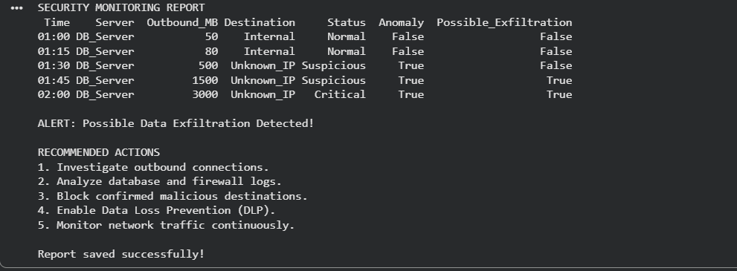
import pandas as pd
data={"Time":["01:00","01:15","01:30","01:45","02:00"],"Server":["DB_Server"]*5,"Outbound_MB":[50,80,500,1500,3000],"Destination":["Internal","Internal","Unknown_IP","Unknown_IP","Unknown_IP"],"Status":["Normal","Normal","Suspicious","Suspicious","Critical"]}
df=pd.DataFrame(data)
baseline=100
df["Anomaly"]=df["Outbound_MB"]>baseline
df["Possible_Exfiltration"]=(df["Outbound_MB"]>1000)&(df["Destination"]=="Unknown_IP")
print("SECURITY MONITORING REPORT")
print(df.to_string(index=False))
if df["Possible_Exfiltration"].any():
print("\nALERT: Possible Data Exfiltration Detected!")
elif df["Anomaly"].any():
print("\nALERT: Unusual Outbound Traffic Detected!")
else:
print("\nStatus: Normal Traffic")
print("\nRECOMMENDED ACTIONS")
print("1. Investigate outbound connections.")
print("2. Analyze database and firewall logs.")
print("3. Block confirmed malicious destinations.")
print("4. Enable Data Loss Prevention (DLP).")
print("5. Monitor network traffic continuously.")
df.to_csv("anomaly_detection_report.csv",index=False)
print("\nReport saved successfully!")

- Tools Used in the IT Industry for Threat Hunting: An IT organization suspects that malware has infected several employee workstations. The security team has access to SIEM software, endpoint detection tools, network traffic analyzers, and vulnerability scanners. Select suitable tools for investigating the incident and explain how each tool can help identify, analyze, and contain the threat. [10]
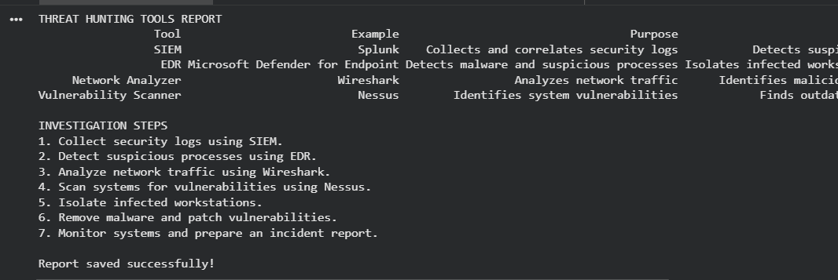
import pandas as pd
data={"Tool":["SIEM","EDR","Network Analyzer","Vulnerability Scanner"],"Example":["Splunk","Microsoft Defender for Endpoint","Wireshark","Nessus"],"Purpose":["Collects and correlates security logs","Detects malware and suspicious processes","Analyzes network traffic","Identifies system vulnerabilities"],"Action":["Detects suspicious login attempts and alerts","Isolates infected workstations and quarantines malware","Identifies malicious IP addresses and connections","Finds outdated software and missing patches"]}
df=pd.DataFrame(data)
print("THREAT HUNTING TOOLS REPORT")
print(df.to_string(index=False))
print("\nINVESTIGATION STEPS")
print("1. Collect security logs using SIEM.")
print("2. Detect suspicious processes using EDR.")
print("3. Analyze network traffic using Wireshark.")
print("4. Scan systems for vulnerabilities using Nessus.")
print("5. Isolate infected workstations.")
print("6. Remove malware and patch vulnerabilities.")
print("7. Monitor systems and prepare an incident report.")
df.to_csv("threat_hunting_tools_report.csv",index=False)
print("\nReport saved successfully!")

- Integrated Threat Hunting and Incident Reporting: A company detects suspicious user logins, connections to a malicious domain, and an unknown process running on an employee workstation. The security team uses Splunk or the ELK Stack to analyze logs and a threat intelligence platform to verify suspicious indicators. Describe the complete threat-hunting process, including data collection, log correlation, threat investigation, malware analysis if required, risk assessment, and preparation of a threat-hunting report with recommended remediation actions. [10]

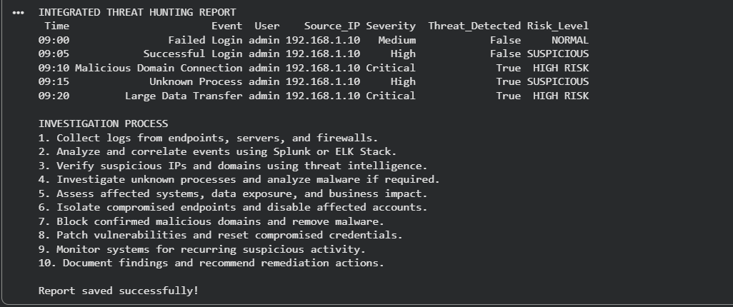

import pandas as pd

data={"Time":["09:00","09:05","09:10","09:15","09:20"],"Event":["Failed Login","Successful Login","Malicious Domain Connection","Unknown Process","Large Data Transfer"],"User":["admin","admin","admin","admin","admin"],"Source_IP":["192.168.1.10"]*5,"Severity":["Medium","High","Critical","High","Critical"]}

df=pd.DataFrame(data)

threat_indicators=["Malicious Domain Connection","Unknown Process","Large Data Transfer"]

df["Threat_Detected"]=df["Event"].isin(threat_indicators)

df["Risk_Level"]=df.apply(lambda r:"HIGH RISK" if r["Severity"]=="Critical" else "SUSPICIOUS" if r["Severity"]=="High" else "NORMAL",axis=1)

print("INTEGRATED THREAT HUNTING REPORT")

print(df.to_string(index=False))

print("\nINVESTIGATION PROCESS")

print("1. Collect logs from endpoints, servers, and firewalls.")

print("2. Analyze and correlate events using Splunk or ELK Stack.")

print("3. Verify suspicious IPs and domains using threat intelligence.")

print("4. Investigate unknown processes and analyze malware if required.")

print("5. Assess affected systems, data exposure, and business impact.")

print("6. Isolate compromised endpoints and disable affected accounts.")

print("7. Block confirmed malicious domains and remove malware.")

print("8. Patch vulnerabilities and reset compromised credentials.")

print("9. Monitor systems for recurring suspicious activity.")

print("10. Document findings and recommend remediation actions.")

df.to_csv("integrated_threat_hunting_report.csv",index=False)

print("\nReport saved successfully!")

